user states

Image3.png

Matej

Table of Contents

Class Diagram1

Table of Figures

Class Diagram1

Class Diagram

# Class Diagram1

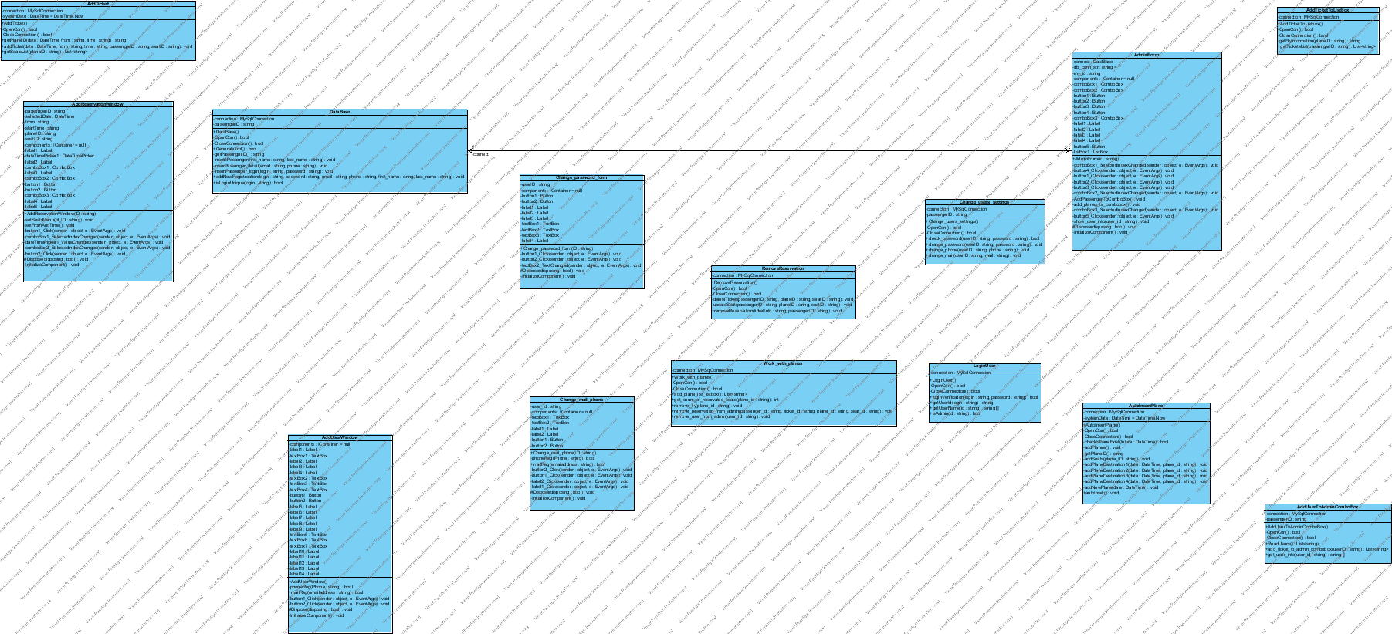

## Image1.png AddReservationWindow

Operations

|  |  |
| --- | --- |
| **Name** | **Description** |
| Image2.png AddReservationWindow |  |
| Image2.png setSeatsMenu |  |
| Image2.png setFromAndTime |  |
| Image2.png button1_Click |  |
| Image2.png comboBox1_SelectedIndexChanged |  |
| Image2.png dateTimePicker1_ValueChanged |  |
| Image2.png comboBox2_SelectedIndexChanged |  |
| Image2.png button2_Click |  |
| Image2.png Dispose | <summary>  Clean up any resources being used.  </summary>  <param name="disposing">true if managed resources should be disposed; otherwise, false.</param> |
| Image2.png InitializeComponent | Required method for Designer support - do not modify  the contents of this method with the code editor. |

## Image1.png AddTicket

Operations

|  |  |
| --- | --- |
| **Name** | **Description** |
| Image2.png AddTicket |  |
| Image2.png OpenCon |  |
| Image2.png CloseConnection |  |
| Image2.png getPlaneID |  |
| Image2.png addTicket |  |
| Image2.png getSeatsList |  |

## Image1.png AddTicketToListbox

Operations

|  |  |
| --- | --- |
| **Name** | **Description** |
| Image2.png AddTicketToListbox |  |
| Image2.png OpenCon |  |
| Image2.png CloseConnection |  |
| Image2.png getFlyInformation |  |
| Image2.png getTicketsList | pridanie do listboxu |

## Image1.png AddUserToAdminComboBox

Operations

|  |  |
| --- | --- |
| **Name** | **Description** |
| Image2.png AddUserToAdminComboBox |  |
| Image2.png OpenCon |  |
| Image2.png CloseConnection |  |
| Image2.png ReadUsers |  |
| Image2.png add_ticket_to_admin_combobox |  |
| Image2.png get_user_info |  |

## Image1.png AddUserWindow

Operations

|  |  |
| --- | --- |
| **Name** | **Description** |
| Image2.png AddUserWindow |  |
| Image2.png phoneReg |  |
| Image2.png mailReg |  |
| Image2.png button1_Click |  |
| Image2.png button2_Click |  |
| Image2.png Dispose | <summary>  Clean up any resources being used.  </summary>  <param name="disposing">true if managed resources should be disposed; otherwise, false.</param> |
| Image2.png InitializeComponent | Required method for Designer support - do not modify  the contents of this method with the code editor. |

## Image1.png AdminForm

Operations

|  |  |
| --- | --- |
| **Name** | **Description** |
| Image2.png AdminForm |  |
| Image2.png comboBox1_SelectedIndexChanged |  |
| Image2.png button4_Click |  |
| Image2.png button1_Click |  |
| Image2.png button2_Click |  |
| Image2.png button3_Click |  |
| Image2.png comboBox2_SelectedIndexChanged |  |
| Image2.png AddPassengerToComboBox |  |
| Image2.png add_planes_to_combobox |  |
| Image2.png comboBox3_SelectedIndexChanged |  |
| Image2.png button5_Click |  |
| Image2.png show_user_info |  |
| Image2.png Dispose | <summary>  Clean up any resources being used.  </summary>  <param name="disposing">true if managed resources should be disposed; otherwise, false.</param> |
| Image2.png InitializeComponent | Required method for Designer support - do not modify  the contents of this method with the code editor. |

## Image1.png AutoInsertPlane

Operations

|  |  |
| --- | --- |
| **Name** | **Description** |
| Image2.png AutoInsertPlane |  |
| Image2.png OpenCon |  |
| Image2.png CloseConnection |  |
| Image2.png checkIsPaneExist |  |
| Image2.png addPlanne |  |
| Image2.png getPlaneID |  |
| Image2.png addSeats |  |
| Image2.png addPlaneDestination1 |  |
| Image2.png addPlaneDestination2 |  |
| Image2.png addPlaneDestination3 |  |
| Image2.png addPlaneDestination4 |  |
| Image2.png addNewPlane |  |
| Image2.png autoInset |  |

## Image1.png DataBase

Operations

|  |  |
| --- | --- |
| **Name** | **Description** |
| Image2.png DataBase |  |
| Image2.png OpenCon |  |
| Image2.png CloseConnection |  |
| Image2.png GenerateXml |  |
| Image2.png getPassengerID |  |
| Image2.png insetrtPassenger |  |
| Image2.png inserPassenger_detail |  |
| Image2.png insertPassenger_login |  |
| Image2.png addNewRegistreation |  |
| Image2.png isLoginUnique |  |

## Image1.png Change_mail_phone

Operations

|  |  |
| --- | --- |
| **Name** | **Description** |
| Image2.png Change_mail_phone |  |
| Image2.png phoneReg |  |
| Image2.png mailReg |  |
| Image2.png button2_Click |  |
| Image2.png button1_Click |  |
| Image2.png label2_Click |  |
| Image2.png label1_Click |  |
| Image2.png Dispose | <summary>  Clean up any resources being used.  </summary>  <param name="disposing">true if managed resources should be disposed; otherwise, false.</param> |
| Image2.png InitializeComponent | Required method for Designer support - do not modify  the contents of this method with the code editor. |

## Image1.png Change_password_form

Operations

|  |  |
| --- | --- |
| **Name** | **Description** |
| Image2.png Change_password_form |  |
| Image2.png button1_Click |  |
| Image2.png button2_Click |  |
| Image2.png textBox2_TextChanged |  |
| Image2.png Dispose | <summary>  Clean up any resources being used.  </summary>  <param name="disposing">true if managed resources should be disposed; otherwise, false.</param> |
| Image2.png InitializeComponent | Required method for Designer support - do not modify  the contents of this method with the code editor. |

## Image1.png Change_users_settings

Operations

|  |  |
| --- | --- |
| **Name** | **Description** |
| Image2.png Change_users_settings |  |
| Image2.png OpenCon |  |
| Image2.png CloseConnection |  |
| Image2.png check_password |  |
| Image2.png change_password |  |
| Image2.png change_phone |  |
| Image2.png change_mail |  |

## Image1.png LoginUser

Operations

|  |  |
| --- | --- |
| **Name** | **Description** |
| Image2.png LoginUser |  |
| Image2.png OpenCon |  |
| Image2.png CloseConnection |  |
| Image2.png loginVerification | funkcia overujuca platnost vstupnych*************************************** |
| Image2.png getUserId |  |
| Image2.png getUserName |  |
| Image2.png isAdmin |  |

## Image1.png Work_with_planes

Operations

|  |  |
| --- | --- |
| **Name** | **Description** |
| Image2.png Work_with_planes |  |
| Image2.png OpenCon |  |
| Image2.png CloseConnection |  |
| Image2.png add_plane_list_listbox |  |
| Image2.png get_count_of_reservated_seats |  |
| Image2.png remove_fly |  |
| Image2.png remove_reservation_from_admin |  |
| Image2.png remove_user_from_admin |  |

## Image1.png RemoveReservation

Operations

|  |  |
| --- | --- |
| **Name** | **Description** |
| Image2.png RemoveReservation |  |
| Image2.png OpenCon |  |
| Image2.png CloseConnection |  |
| Image2.png deleteTicket |  |
| Image2.png updateSeat |  |
| Image2.png removeReservation |  |